SALSA Day of Action
Social Media Toolkit

On Tuesday April 16, ACLA, in collaboration with our associate members, patient and provider organization partners, is hosting a SALSA Day of Action to urge Congress to pass the Saving Access to Laboratory Services Act (SALSA) that would secure long-term PAMA reform. This social media tool kit features new creative and because the week of April 14 is Medical Laboratory Professionals Week, we have included below creative that thanks our nation’s laboratorian professionals, underscoring the need for SALSA passage to protect the work they do each day on behalf of patients.

Here’s what you can do:

- Visit StopLabCuts.org, ACLA’s SALSA campaign hub, and use the “take action,” tool to send an email to your Members of Congress, letting them know that protecting access to clinical laboratory services is important to you. Over the past 2 years, this effort has generated 200,000 messages to Capitol Hill in support of SALSA.

- Share your support for SALSA on social media (X, formerly known as Twitter, or LinkedIn) using the sample graphics and suggested text below to post, “like” and share/repost these messages.

Please contact Holly Grosholz, ACLA’s Senior Director of Government Affairs, at hgrosholz@acla.com for more information. For the latest campaign updates, background and content please visit StopLabCuts.org

Social Copy | Graphic
Passing the Saving Access to Laboratory Services Act (#SALSA) will protect patient access to testing, critical clinical laboratory infrastructure, and innovation in tomorrow’s diagnostics. Visit the #StopLabCuts website to learn more: https://stoplabcuts.org. | 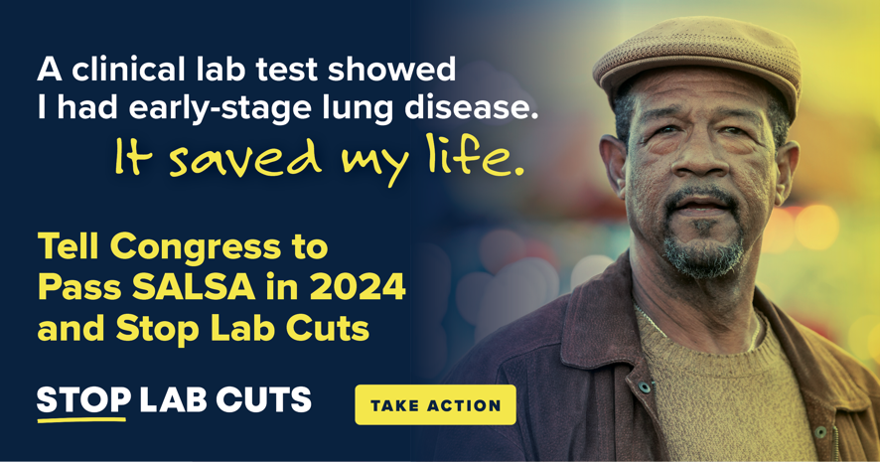
Over 65 million seniors rely on clinical lab testing to diagnose and manage conditions. Without action, about 800 tests will face payment cuts, threatening access to care. Tell Congress to pass the Saving Access to Laboratory Services Act (#SALSA): https://stoplabcuts.org. | 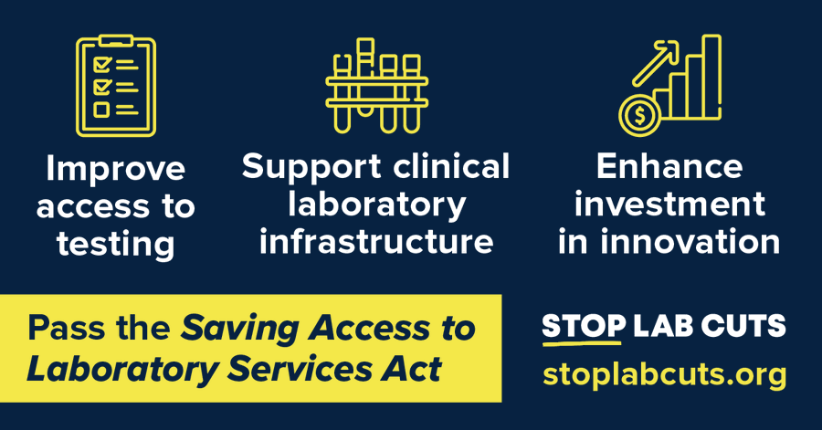
Diagnostic tests performed by clinical laboratorians inform some of life’s most important health care decisions. This #LabWeek, we’re calling on Congress to protect access to these tests by passing the Saving Access to Laboratory Services Act (#SALSA): https://stoplabcuts.org/. | 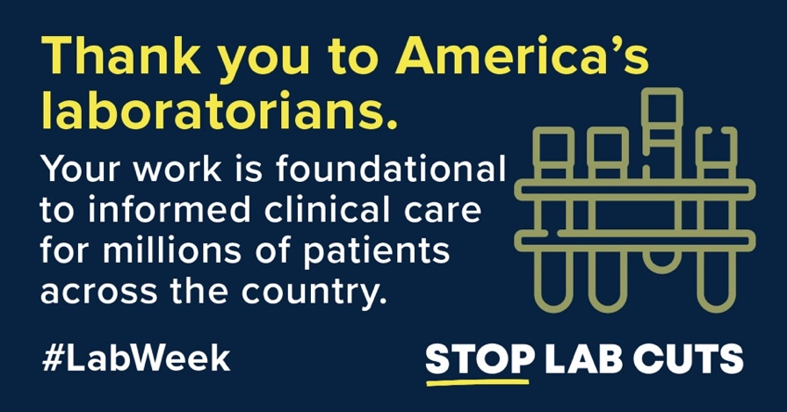
Scheduled Medicare cuts may jeopardize access to many laboratory tests patients rely on. This #LabWeek, tell Congress to #StopLabCuts and pass the Saving Access to Laboratory Services Act (#SALSA): https://stoplabcuts.org/. | 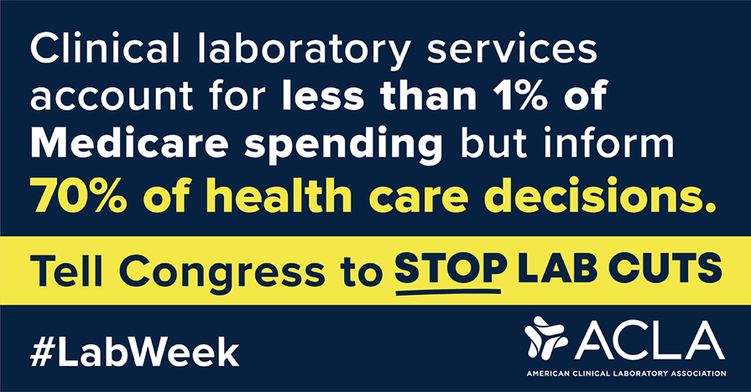
Strong clinical laboratories are foundational to the U.S. health care system. As we commemorate #LabWeek and celebrate America’s laboratorians, we call on Congress to pass the Saving Access to Laboratory Services Act (#SALSA): https://stoplabcuts.org/. | 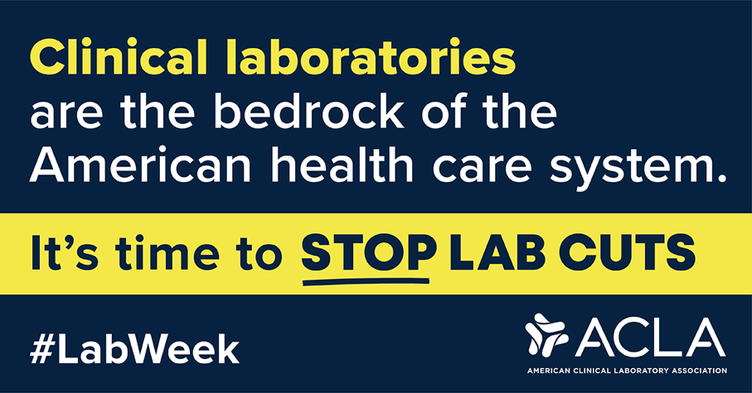
Thank you to America’s clinical laboratorians for the critical role they play in shaping the health care of millions of patients nationwide. This #LabWeek, we urge Congress to #StopLabCuts and pass the Saving Access to Laboratory Services Act (#SALSA): https://stoplabcuts.org/. | 