Medical Laboratory Professionals Week (April 14-20)
Social Toolkit

ACLA is pleased to celebrate Medical Laboratory Professionals Week, April 14-20, an annual observance that presents an important opportunity to uplift and show appreciation for America’s laboratory professionals.

Below you will find social media cards and suggested text that can be used on X (formerly known as Twitter), LinkedIn, or the social media platform of your choice. We invite you to join with ACLA and take a moment to post, “like” and share/repost these messages as we demonstrate our support for medical laboratory professionals whose work in clinical laboratories is foundational to patient care and our healthcare system.

This toolkit includes co-branded content with The American Society for Clinical Laboratory Science (ASCLS). We are pleased to collaborate with ASCLS and amplify the collective voice of the clinical diagnostics industry.

We hope you find this content helpful. For more information, please contact Holly Grosholz at hgrosholz@acla.com

Social Copy | Graphic
This #LabWeek, we thank America’s laboratorians for their tireless efforts each day to deliver essential health information that provides a path forward for life-changing – and life-saving – treatment and care. #ThePowerOfKnowing | 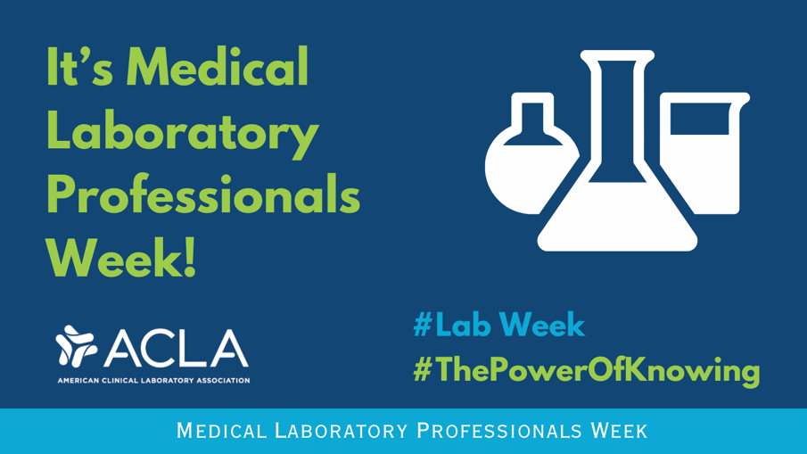
This #LabWeek, we acknowledge the nation’s laboratorians whose hard work, expertise, and unwavering dedication helps deliver essential diagnostic health information to patients and providers. #ThePowerOfKnowing | 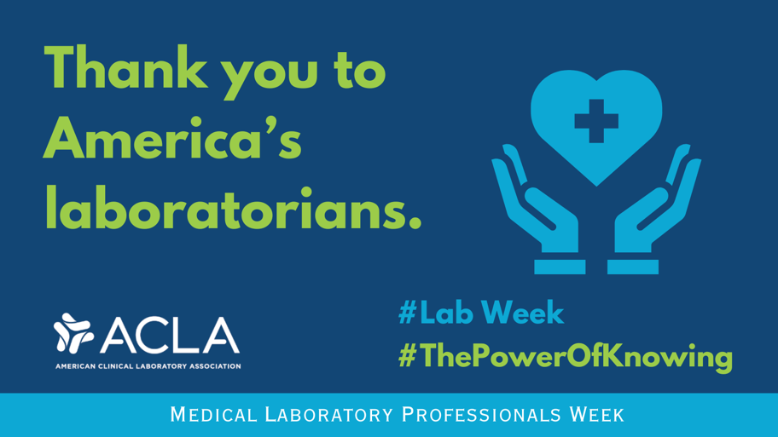
Thank you to the thousands of laboratorians who serve as the foundation for public health preparedness and response and for everyday prevention, diagnosis, and treatment of disease for patients across the country. #ThePowerOfKnowing #LabWeek | 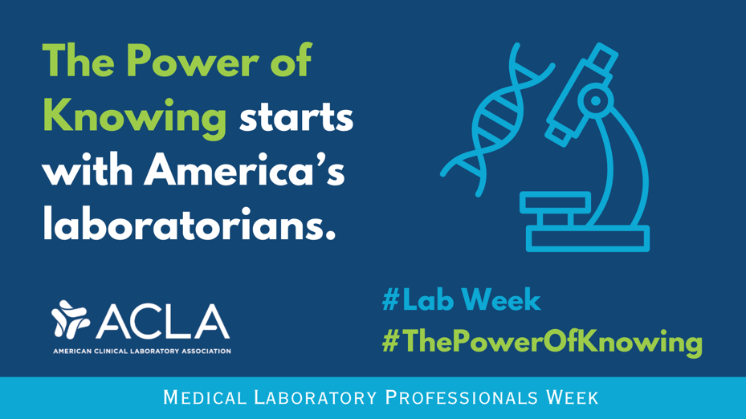
This #LabWeek, I’m grateful for medical laboratory professionals who work tirelessly to ensure patients receive accurate and timely diagnoses that inform subsequent care. | 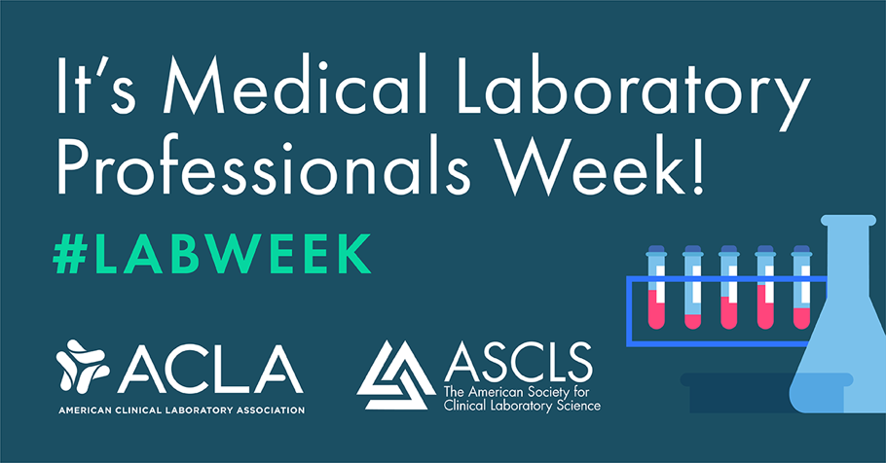
Happy #LabWeek to America's laboratorians! Your unwavering commitment to precision and care drives improved health outcomes every day. Thank you for the vital role you play within our nation's health care system. #labvocates | 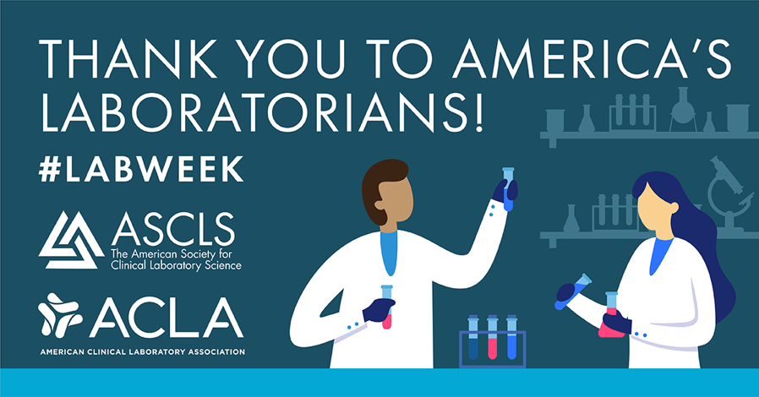
Every day, laboratorians nationwide provide essential health information to patients and providers. This #LabWeek, we recognize their important role in informing evidence-based health care decisions. | 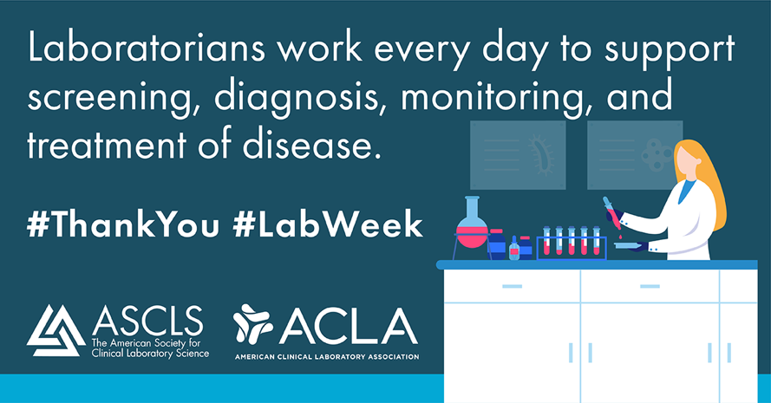
As a #labvocate, I urge Congress to pass the Saving Access to Laboratory Services Act. If enacted, #SALSA will protect patient access to over 800 laboratory tests. #LabWeek #StopLabCuts | 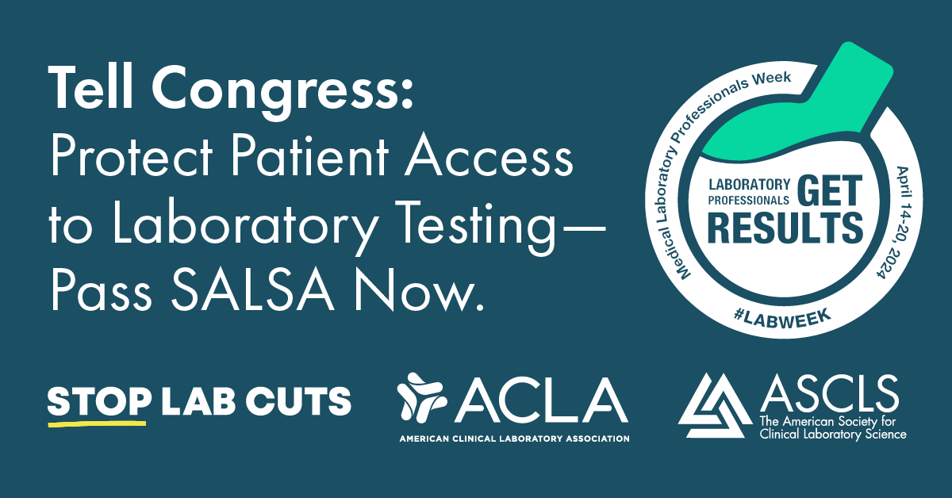
Congress: it’s time to pass the Saving Access to Laboratory Services Act (#SALSA) and safeguard patient access to clinical laboratory testing. As a #labvocate, I am passionate about patient health and protecting our nation’s health care infrastructure. #StopLabCuts | 